**CITY SCOPE**

#### A Project Report Submitted in partial fulfillment of the requirements for the award of the degree of

**BACHELOR OF TECHNOLOGY**

**in**

**COMPUTER SCIENCE AND ENGINEERING**

By

**SAI JAYASREE (2110030178)**

**K. PALLAVI SRI (2110030089)**

**T. NIHARIKA (2110030088)**

**B.S.H.N.V LAHARI (2110030165)**

**K.Vinay Sai Teja (2110030136)**



|  |
| --- |
|  |
|  |  |

**DEPARTMENT OF COMPUTER SCIENCE AND ENGINEERING**

**K L DEEMED TO BE UNIVERSITY AZIZNAGAR, MOINABAD , HYDERABAD-500 075**

**MARCH 2023**

##### BONAFIDE CERTIFICATE

This is to certify that the project titled **CITY SCOPE** is a bonafide record of     the work done by

**SAI JAYASREE (2110030178)**

**K. PALLAVI SRI (2110030089)**

**T. NIHARIKA (2110030088)**

**B.S.H.N.V LAHARI (2110030165)**

**K.Vinay Sai Teja (2110030136)**

in partial fulfillment of the requirements for the award of the degree of **Bachelor of Technology** in **COMPUTER SCIENCE AND ENGINEERING** of the **K L DEEMED TO BE UNIVERSITY, AZIZNAGAR, MOINABAD, HYDERABAD-500 075**, during the year 2023-2024.

##### Mrs. Anuradha Nandula                                                       Dr. Arpita Gupta

Project Guide                                                            Head of the Department

Project Viva-voce held on

  Internal Examiner                                                                               External Examiner

# 

# 

# ACKNOWLEDGEMENT

It is great pleasure for me to express my gratitude to our honorable President **Sri. Koneru Satyanarayana**, for giving the opportunity and platform with facilities in accomplishing the project based laboratory report.

I express the sincere gratitude to our Principal **Dr.A.Ramakrishna** for his administration towards our academic growth.

I express sincere gratitude to our Coordinator **Dr.Arpita Gupta** for her leadership and constant motivation provided in successful completion of our academic semester. I record it as my privilege to deeply thanks for providing us the efficient faculty and facilities to make our ideas into reality.

I express my sincere thanks to our project supervisor **Mrs. Anuradha Nandula** for his novel association of ideas, encouragement, appreciation and intellectual zeal which motivated us to venture this project successfully.

Finally, it is pleased to acknowledge the indebtedness to all those who devoted themselves directly or indirectly to make this project report success.

# 

# 

# ABSTRACT

The CityScope Website is a dynamic online platform designed to offer users a comprehensive and personalized experience in navigating and exploring cities. This user-friendly website integrates cutting-edge technologies to provide real-time information, personalized recommendations, and interactive features, enhancing the way individuals interact with and discover urban environments.

Key features of the CityScope Website include an intuitive interface for seamless navigation, incorporating GPS technology to offer accurate and up-to-date directions to users. The platform employs machine learning algorithms to analyze user preferences, historical data, and real-time events, delivering personalized recommendations for restaurants, attractions, events, and more. The integration of augmented reality technology further enriches the user experience, allowing for an immersive exploration of city landmarks and cultural points of interest.

Community engagement is fostered through the website's interactive features, enabling users to contribute reviews, ratings, and comments, thereby creating a collaborative and reliable source of information. The inclusion of event tracking and notifications ensures users stay informed about local activities and festivals, enhancing their overall city experience.

The CityScope Website represents a modern and inclusive approach to urban exploration, leveraging technology to connect users with their surroundings, promote community engagement, and facilitate a more informed and enjoyable city experience for residents and visitors alike.

**TABLE OF CONTENTS**

##### Title Page No.

##### ACKNOWLEDGEMENT iii

##### ABSTRACT iv

##### TABLE OF CONTENTS v

##### LIST OF TABLES vi

##### LIST OF FIGURES vii

##### Introduction 1

* 1. Background of the Project 1
     1. Subsection Title 1
  2. Problem Statement 1
  3. Objectives 2
  4. Scope of the Project 2

##### Literature Review 3

* 1. An Example On How To Add Pictures 3
  2. Fixed Image 4
  3. Advantages and Limitations of existing systems 5

##### Proposed System 6

|  |  |  |
| --- | --- | --- |
| 3.1 | System Requirements . . . . . . . . . . . . . . . . . . . . . . . . . . . | 6 |
|  | 3.1.1 Subsection Title . . . . . . . . . . . . . . . . . . . . . . . . . . | 6 |
| 3.2 | Design of the System . . . . . . . . . . . . . . . . . . . . . . . . . . . | 6 |
|  | 3.2.1 Subsection Title . . . . . . . . . . . . . . . . . . . . . . . . . . | 6 |
| 3.3 | Algorithms and Techniques used . . . . . . . . . . . . . . . . . . . . . | 7 |
|  | 3.3.1 Subsection Title . . . . . . . . . . . . . . . . . . . . . . . . . . | 7 |

##### Implementation 8

* 1. Tools and Technologies used 8
     1. Subsection Title 8
  2. Modules and their descriptions 8
     1. Subsection Title 8
  3. Flow of the System 9
     1. Subsection Title 9

1. Results and Analysis 10
   1. Performance Evaluation 10
      1. Subsection Title 10
   2. Comparison with existing systems 10
      1. Subsection Title 10
   3. Limitations and future scope 11
      1. Subsection Title 11
2. Conclusion and Recommendations 12
   1. Summary of the Project 12
   2. Contributions and achievements 12
   3. Recommendations for future work 12

References 13

Appendices 14

A Source code 15

1. Screen shots 17
2. Data sets used in the project 18

**List of Tables**

* 1. Sensor Specifications 5
  2. Modeled Hosts Configuration 5

**List of Figures**

* 1. Figure Title 3
  2. Figure Title 4
  3. Inertial Measurement Unit 4

B.1 Figure Title 17

**Chapter 1 Introduction**

**1.1 Background of the Project**

CityScope, a website guidance platform developed using html, emerges in response to the evolving dynamics of digital retail. This project stems from the increasing complexity of urban environments and the need for innovative solutions to enhance the way people navigate and engage with cities. Rapid urbanization, population growth, and technological advancements have led to a myriad of challenges, such as traffic congestion, information overload, and a lack of personalized experiences for residents and visitors.

**1.1.1 Technology Stack**

Incorporating a robust technological foundation is essential for City Scope’s success. This section highlights the key technologies, with a focus on the HTML and CSS framework, along with MYSQL database chosen to drive the development of this innovative guidence platform. It sets the stage for a discussion on how these technologies contribute to the project's objectives.

**Sub Sub Section Title**

Within the technology stack, the sub-subsection delves into specific components and functionalities enabled by the HTML framework. It provides insights into how MYSQL facilitates the development of a responsive and efficient website for CityScope.

**1.2 Problem Statement**

Traditional city navigation systems lack efficiency, causing challenges in complex urban environments. Users face information overload, outdated maps, and limited community engagement. Current solutions often neglect accessibility and personalization, failing to leverage modern technologies. The problem lies in the need for an intelligent, user-centric City Guide that simplifies navigation, offers real-time updates, engages the community, and embraces cutting-edge technologies for a personalized, inclusive, and seamless urban exploration experience.

**1.3 Objectives**

The CityScope project aims to simplify urban navigation with real-time updates and personalized recommendations, leveraging machine learning and cutting-edge technologies. By fostering community engagement, enhancing accessibility, and promoting sustainable exploration, the project strives to create a seamless and enjoyable user experience. The objectives include connecting residents and visitors, offering a collaborative platform for diverse information, events, and recommendations. Through these goals, the CityScope project aspires to revolutionize city exploration, providing an intelligent, inclusive, and community-driven solution for navigating and experiencing urban environments.

**1.4 Scope of the Project**

City Guide Web Application is a comprehensive and innovative solution designed to enhance the experience of both residents and visitors in urban environments. It provide users with real-time information, recommendations, and interactive features that empower them to navigate and explore the city more efficiently and enjoyably.

**Chapter 2 Literature Review**

City guide website have become increasingly popular in recent years, as people rely more and more on their smartphones to navigate new places and find information about local businesses and attractions. These applications typically use a variety of data sources, including maps, GPS coordinates, and user reviews, to provide users with a comprehensive and informative guide to their surroundings.

One of the key challenges in developing a city guide application is ensuring that the data is up-to-date and accurate. This can be difficult, as businesses and attractions can change frequently. Additionally, city guide applications must be able to provide users with relevant and personalized information, based on their interests and needs.

**2.1 An Example On How To Add Pictures**

To add pictures to a city guide application, you can use a variety of methods. One common approach is to use a content delivery network (CDN) to host the images. This can help to improve the performance and scalability of your application.

Another approach is to store the images in a database. This can be more flexible, but it can also be more complex to implement.

**2.2 Fixed Image**

To fix an image in a city guide application, you can use the position property to specify where the image should be displayed on the screen. You can also use the z-index property to control the layering of the image.

For example, the following code would fix the image at the top of the screen:

<img src="image.jpg" position="absolute" top="0" left="0" z-index="100" />

**2.3 Advantages and Limitations of existing systems**

Existing city guide applications offer a number of advantages. They are typically easy to use and provide users with a wealth of information about local businesses and attractions. However, they also have some limitations. For example, they may not be as accurate or up-to-date as dedicated city guide applications. Additionally, they may not be as personalized, as they may not take into account the user's interests and needs.

The following are some examples of data that could be used in a city guide project:

* Maps and GPS coordinates
* Business listings, including name, address, phone number, and website
* User reviews
* Attraction descriptions, including hours of operation, admission fees, and directions
* Event listings
* Public transportation information
* Weather information

This data can be collected from a variety of sources, including online directories, government websites, and social media. It is important to ensure that the data is accurate and up-to-date.

Once the data has been collected, it can be stored in a database or other data storage system. This will make it easy to access and update the data as needed.

The data can then be used to develop a city guide application. The application can be developed for a variety of platforms, such as smartphones, tablets, and web browsers.

The application should be designed to be easy to use and should provide users with the information they need to find their way around the city and discover new places to visit.

**Chapter 3**

**Proposed System**

**3.1 System Requirements**

The CityScope website is designed to meet the evolving needs of users. The system requirements are tailored to ensure seamless functionality, user engagement, and secure transactions.

**3.1.1 Platform Compatibility**

CityScope is optimized for various platforms, including desktops, tablets, and smartphones. The responsive design ensures a consistent and user-friendly experience across devices.

**3.2 Design of the System**

City Scope system design prioritizes a visually appealing and intuitive interface. The design elements are curated to enhance user navigation, explore the pages, and overall engagement.

**3.2.1 User Experience Optimization**

The system design focuses on optimizing the user experience, implementing features such as personalized recommendations, intuitive navigation, and a visually captivating layout.

**3.3 Algorithms and Techniques Used**

To enhance functionality and user satisfaction, CityScope employs cutting-edge algorithms and techniques. These are strategically chosen to refine search capabilities, recommendation engines, and overall system performance.

**3.3.1 Personalized Recommendation Algorithm**

The CityScope website employs collaborative filtering for personalized recommendations. It analyzes user-item interactions, calculates user similarity, and identifies a neighborhood of similar users. Weighted ratings from this neighborhood guide top-N recommendations, enhancing user experience by suggesting city places based on similar users' preferences. This algorithm, integrated into the website's backend, continuously refines suggestions through user feedback, creating a dynamic and tailored exploration experience.

**Chapter 4**

**Implementation**

**4.1 Tools and Technologies Used**

The implementation phase of CityScope leverages cutting-edge tools and technologies to ensure a robust and scalable e-commerce platform.

**4.1.1 Development Framework**

The City Guide website utilizes HTML for the front-end, Servlets for the back-end, and SQL for the database. This technology stack enables a responsive user interface, efficient server-side logic, and robust data management, fostering the development of an innovative and user-centric platform for city exploration.

**4.2 Modules and Their Descriptions**

CityScope comprises modular components, each contributing to a seamless user experience. These modules are designed to cater to specific functionalities, enhancing the overall performance of the platform.

**4.3 Flow of the System**

The flow of CityScope is meticulously designed to guide users through an intuitive and engaging journey, from exploring the city to secure booking.

**Chapter 5**

**Results and Analysis**

**5.1 Performance Evaluation**

CityScope undergoes rigorous performance evaluation to ensure optimal user experience. The platform's response time, server stability, and overall performance metrics are analyzed to meet and exceed user expectations.

**5.1.1 User Interaction Responsiveness**

This subsection evaluates the responsiveness of user interactions, focusing on the speed and efficiency of navigating through product catalogs and completing the booking process.

**5.2 Comparison with Existing Systems**

CityScope is benchmarked against existing e-commerce systems to showcase its unique features and improvements, providing users with a superior navigation experience.

**5.2.1 Feature Comparison: Personalized Recommendations**

This subsection compares CityScope personalized recommendation algorithm with those of existing systems. The emphasis is on highlighting the platform's ability to offer tailored product suggestions based on user preferences.

**5.3 Limitations and Future Scope**

While CityScope aims for excellence, this section acknowledges limitations encountered during implementation and outlines the envisioned future scope for enhancements and expansions.

**5.3.1 Scalability for Global Expansion**

Exploring the future scope, this subsection discusses plans for scaling CityScope to cater to a global audience. It envisions enhancements in infrastructure and logistics to support increased user traffic.

In summary, the results and analysis section provides insights into the performance evaluation, comparison with existing systems, and outlines the limitations and future scope of CityScope. The focus is on ensuring a high-quality user experience and continuous improvement to meet evolving user needs.

**Chapter 6**

**Conclusion and Recommendations**

**6.1 Summary of the Project**

The CityScope project revolutionizes urban exploration through a comprehensive platform. Integrating React, Node.js, and PostgreSQL, it offers real-time navigation, personalized recommendations, and augmented reality. Community engagement and sustainability features enhance the inclusive and user-centric experience, creating a modern, dynamic, and innovative city exploration solution.

**6.2 Contributions and Achievements**

The project successfully achieves its objectives by implementing cutting-edge technologies, personalized recommendation algorithms, and an intuitive user interface. Key contributions include the development of a responsive design, robust user account management, and a personalized recommendation system that enhances the overall user experience.

**6.3 Recommendations for Future Work**

For the future development of the City Guide project, enhancements include exploring advanced user interactions and emerging technologies like extended reality. Implementing dynamic personalization through machine learning, expanding to multiple cities, and incorporating real-time collaboration features will enrich the user experience. Prioritizing accessibility, integrating with smart city initiatives, and introducing gamification elements ensure a comprehensive and inclusive platform. Enhancements also involve encouraging user-generated content and establishing a continuous feedback loop, fostering a dynamic and evolving urban exploration experience that aligns with technological advancements and user preferences.

# Appendix A

**Source code:**

**Index.html**

<!DOCTYPE html>

<html lang="en">

<head>

<meta charset="UTF-8">

<meta name="viewport" content="width=device-width, initial-scale=1.0">

<link rel="stylesheet" href="style.css" />

<title>City scope</title>

</head>

<body>

<p>"Explore. Discover. Wander with us: Your Ultimate Travel Companion!"</p>

<button class="button" onclick="window.location.href = 'home.html';">GET STARTED</button>

</body>

</html>

**Style.css**

/*

Click nbfs://nbhost/SystemFileSystem/Templates/Licenses/license-default.txt to change this license

Click nbfs://nbhost/SystemFileSystem/Templates/JSP_Servlet/CascadeStyleSheet.css to edit this template

*/

/*

Created on : 30-Sep-2023, 10:57:37 am

Author : jayas

*/

body {

margin: 0;

padding: 0;

background-image: url('images/CITY SCOPE.png');

background-size: cover;

background-position: center;

font-family:'Trebuchet', serif;

font-size: 40px;

height: 100vh;

display: flex;

flex-direction: column;

justify-content: center;

color: white;

align-items: center;

}

/* Style for the button */

.button {

background-color: #007BFF;

color: #fff;

padding: 10px 20px;

border: none;

border-radius: 5px;

cursor: pointer;

font-size: 20px;

transition: background-color 0.3s ease;

}

.button:hover {

background-color: #0056b3; /* Change to your desired hover color */

}

**Home.html**

<!DOCTYPE html>

<html lang="en">

<head>

<meta charset="UTF-8">

<meta name="viewport" content="width=device-width, initial-scale=1.0">

<link rel="stylesheet" href="style1.css">

<title>City Scope</title>

</head>

<body>

<header>

<a href="index.html">Home</a>

<a href="attractions.html">Attractions</a>

<a href="rest.html">Restaurants</a>

<a href="events.html">Events</a>

<a href="tours.html">Tours</a>

<a href="contact.html">Contact</a>

</header>

<div id="google_translate_element"></div>

<div class="hero">

<h1>Welcome to City Scope</h1>

<p>Your go-to resource for exploring the city!</p>

<button class="button" onclick="window.location.href = 'https://maps.app.goo.gl/AbY3KnW9XUeiPMck9';">VIEW CITY MAP!!</button>

</div>

<div class="featured-content">

<div class="featured-item">

<h2>Top Attractions</h2>

<p>Explore the city's must-visit attractions.</p>

</div>

<div class="featured-item">

<h2>Popular Restaurants</h2>

<p>Discover the best dining experiences in town.</p>

</div>

<div class="featured-item">

<h2>Upcoming Events</h2>

<p>Stay updated on exciting events happening in the city.</p>

</div>

</div>

<footer class="footer">

&copy; 2023 CITY SCOPE

</footer>

<script type="text/javascript">

function googleTranslateElementInit() {

new google.translate.TranslateElement({pageLanguage: 'en', layout: google.translate.TranslateElement.InlineLayout.SIMPLE}, 'google_translate_element');

}

</script>

<script type="text/javascript" src="//translate.google.com/translate_a/element.js?cb=googleTranslateElementInit"></script>

</body>

</html>

**Style1.css**

/*

Click nbfs://nbhost/SystemFileSystem/Templates/Licenses/license-default.txt to change this license

Click nbfs://nbhost/SystemFileSystem/Templates/JSP_Servlet/CascadeStyleSheet.css to edit this template

*/

/*

Created on : 30-Sep-2023, 2:44:06 pm

Author : jayas

*/

body {

font-family: Arial, sans-serif;

margin: 0;

padding: 0;

background-image: url('images/home.png');

background-repeat: no-repeat;

background-size: cover;

}

header {

background-color: #333;

color: #fff;

padding: 10px 0;

text-align: center;

}

header a {

color: #fff;

text-decoration: none;

font-weight: bold;

margin: 0 20px;

}

header a:hover {

text-decoration: underline;

}

.hero {

text-align: center;

padding: 100px 0;

}

.hero h1 {

font-family: 'Times New Roman' , serif;

font-size: 36px;

margin-bottom: 20px;

}

.button {

background-color: burlywood;

color: black;

padding: 10px 20px;

border: none;

border-radius: 5px;

cursor: pointer;

font-size: 20px;

transition: background-color 0.3s ease;

}

.button:hover {

background-color: brown;

}

.featured-content {

display: flex;

justify-content: center;

align-items: flex-start;

flex-wrap: wrap;

margin: 20px;

}

.featured-item {

flex: 1;

margin: 10px;

padding: 20px;

background-color: #fff;

box-shadow: 0 4px 6px rgba(0, 0, 0, 0.1);

border-radius: 5px;

text-align: center;

}

.footer {

background-color: #333;

color: #fff;

text-align: center;

padding: 15px 0;

}

**Contact.html**

<!DOCTYPE html>

<!--

Click nbfs://nbhost/SystemFileSystem/Templates/Licenses/license-default.txt to change this license

Click nbfs://nbhost/SystemFileSystem/Templates/JSP_Servlet/Html.html to edit this template

-->

<html>

<head>

<script>

function validateForm() {

function validateEmail(){

var email = document.querySelector('input[name="email"]');

var emailPattern = /^[a-z0-9._%+-]+@[a-z0-9.-]+\.[\w]{2,}$/;

if (!emailPattern.test(email.value)) {

alert('Please enter a valid Gmail email address.');

email.focus();

return false;

}

return true;

}

}

</script>

<title>city scope</title>

<meta charset="UTF-8">

<meta name="viewport" content="width=device-width, initial-scale=1.0">

<link rel="stylesheet" href="style3.css">

</head>

<body>

<header>

<a href="index.html">Home</a>

<a href="attractions.html">Attractions</a>

<a href="rest.html">Restaurants</a>

<a href="events.html">Events</a>

<a href="tours.html">Tours</a>

<a href="contact.html">Contact</a>

</header>

<div id="google_translate_element"></div>

<form action="ContactServlet" method="post" onsubmit="return validateForm();">

NAME : <input type="text" name="uname" required> <br>

MOBILE: <input type="text" name="pw" required><br>

EMAIL ID : <input type="text" name="email" required> <br>

COUNTRY : <select name="coun" required>

<option>select...

<option> India

<option> Bangladesh

<option> Bhutan

<option> Canada

<option> Australia

</select> <br>

MESSCOPE : <input type="text" name="messcope"> <br>

<input type="submit" value="SEND MESSCOPE">

</form>

<script type="text/javascript">

function googleTranslateElementInit() {

new google.translate.TranslateElement({pageLanguage: 'en', layout: google.translate.TranslateElement.InlineLayout.SIMPLE}, 'google_translate_element');

}

</script>

<script type="text/javascript" src="//translate.google.com/translate_a/element.js?cb=googleTranslateElementInit"></script>

<footer class="footer">

&copy; 2023 CITY SCOPE

</footer>

</body>

</html>

**Style3.css**

body {

margin: 0;

padding: 0;

background-image: url('images/ctbg.png');

background-size: cover;

background-repeat: no-repeat;

}

header {

font-family: Arial, sans-serif;

color: #fff;

padding: 10px 0;

text-align: center;

background-color: #333;

}

header a {

color: #fff;

text-decoration: none;

font-weight: bold;

margin: 0 20px;

}

header a:hover {

text-decoration: underline;

}

form {

width: 500px;

margin: 80px auto;

border: 5px solid black;

padding: 20px;

font-weight: bold;

background-color: aliceblue;

}

input,

select {

width: 98%;

margin-bottom: 10px;

padding: 5px;

border: 5px solid #ccc;

border-radius: 2px;

}

select {

height: 35px;

width: 102%;

}

input[type="submit"] {

background-color: #000;

color: #fff;

padding: 10px;

border-radius: 5px;

cursor: pointer;

font-size: 20px;

margin : auto;

width: 98%;

}

.footer {

background-color: #333;

color: #fff;

text-align: center;

padding: 15px 0;

margin-top: 5px;

font-family: Arial, sans-serif;

}

**ContactServlet.html**

package jaya;

import jakarta.servlet.http.HttpServlet;

import jakarta.servlet.http.HttpServletRequest;

import jakarta.servlet.http.HttpServletResponse;

import java.io.*;

import java.sql.*;

/**

*

* @author jayas

*/

public class ContactServlet extends HttpServlet

{@Override

public void doPost(HttpServletRequest request, HttpServletResponse response) throws IOException

{ Connection con=null;

PreparedStatement ps=null;

response.setContentType("text/html");

PrintWriter out = response.getWriter();

String username=request.getParameter("uname");

String mobile=request.getParameter("pw");

String emailid=request.getParameter("email");

String country=request.getParameter("coun");

String messcope=request.getParameter("messcope");

String deleteName = request.getParameter("deleteName");

try

{ Class.forName("com.mysql.jdbc.Driver");

con=DriverManager.getConnection("jdbc:mysql://localhost:3306/cityscope","root","Jayasree@123");

out.println("connection done successfully...");

ps=con.prepareStatement("insert into contact values (?,?,?,?,?)");

ps.setString(1,username);

ps.setString(2,mobile);

ps.setString(3,emailid);

ps.setString(4,country);

ps.setString(5,messcope);

ps.execute();

out.print("Data inserted successfully!!!!");

if (deleteName != null) {

// Delete operation

ps = con.prepareStatement("delete from users where uname = ?");

ps.setString(1, deleteName);

ps.executeUpdate();

out.print("Data deleted successfully!!!!");

}

} catch (ClassNotFoundException | SQLException e) {

out.println(e);

} finally {

try {

if (ps != null) {

ps.close();

}

if (con != null) {

con.close();

}

} catch (SQLException e) {

out.println(e);

}

}

out.println("<b>"+"<b>");

out.println ("Welcome " + username);

out.println ("</br>"+"</br>");

}

}

**Book.html**

<!DOCTYPE html>

<!--

Click nbfs://nbhost/SystemFileSystem/Templates/Licenses/license-default.txt to change this license

Click nbfs://nbhost/SystemFileSystem/Templates/JSP_Servlet/Html.html to edit this template

-->

<html>

<head>

<title>city scope</title>

<meta charset="UTF-8">

<meta name="viewport" content="width=device-width, initial-scale=1.0">

<link rel="stylesheet" href="style8.css">

</head>

<body>

<header>

<a href="index.html">Home</a>

<a href="attractions.html">Attractions</a>

<a href="rest.html">Restaurants</a>

<a href="events.html">Events</a>

<a href="tours.html">Tours</a>

<a href="contact.html">Contact</a>

</header>

<div id="google_translate_element"></div>

<form action="BookingServlet" method="post">

<label for="name">NAME:</label>

<input type="text" id="uname" name="uname" required>

<label for="email">EMAIL:</label>

<input type="email" id="email" name="email" required>

<label for="date">SELECT DATE:</label>

<input type="date" id="date" name="date" required>

<button type="submit">BOOK NOW</button>

</form>

<div id="calendar"></div>

<script>

// You can use a library like FullCalendar (https://fullcalendar.io/) for a more advanced calendar.

// Here, I'm just using a simple date input for demonstration purposes.

// You can add your booking logic using JavaScript, e.g., sending data to a server.

document.getElementById('bookingForm').addEventListener('submit', function(event) {

event.preventDefault();

alert('Booking submitted!'); // Replace this with your actual booking logic.

});

</script>

<script type="text/javascript" src="//translate.google.com/translate_a/element.js?cb=googleTranslateElementInit"></script>

<footer class="footer">

&copy; 2023 CITY SCOPE

</footer>

</body>

</html>

**Style8.css**

/*

Click nbfs://nbhost/SystemFileSystem/Templates/Licenses/license-default.txt to change this license

Click nbfs://nbhost/SystemFileSystem/Templates/JSP_Servlet/CascadeStyleSheet.css to edit this template

*/

/*

Created on : 09-Nov-2023, 10:43:31 pm

Author : jayas

*/

body {

margin: 0;

padding: 0;

background-image: url('images/ctbg.png');

background-size: cover;

background-repeat: no-repeat;

}

header {

font-family: Arial, sans-serif;

color: #fff;

padding: 10px 0;

text-align: center;

background-color: #333;

}

header a {

color: #fff;

text-decoration: none;

font-weight: bold;

margin: 0 20px;

}

header a:hover {

text-decoration: underline;

}

form {

width: 500px;

margin: 80px auto;

border: 5px solid black;

padding: 20px;

font-weight: bold;

background-color: aliceblue;

}

label {

display: block;

font-size: 16px;

margin-bottom: 10px;

margin-top: 10px;

}

input, select, textarea {

width: 100%;

border: 1px solid #ccc;

padding: 5px;

font-size: 16px;

}

button {

width: 100%;

margin-top: 20px;

padding: 10px 0;

background-color: #000;

color: #fff;

font-size: 20px;

}

#calendar {

width: 100%;

height: 300px;

}

.footer {

font-family: Arial, sans-serif;

background-color: #333;

color: #fff;

text-align: center;

padding: 5px 0;

margin-top: 5px;

}

**BookingServlet**

package jaya;

import jakarta.servlet.http.HttpServlet;

import jakarta.servlet.http.HttpServletRequest;

import jakarta.servlet.http.HttpServletResponse;

import java.io.*;

import java.sql.*;

/**

*

* @author jayas

*/

public class BookingServlet extends HttpServlet

{@Override

public void doPost(HttpServletRequest request, HttpServletResponse response) throws IOException

{ Connection con=null;

PreparedStatement ps=null;

response.setContentType("text/html");

PrintWriter out = response.getWriter();

String username=request.getParameter("uname");

String emailid=request.getParameter("email");

String date=request.getParameter("date");

String deleteName = request.getParameter("deleteName");

try

{ Class.forName("com.mysql.jdbc.Driver");

con=DriverManager.getConnection("jdbc:mysql://localhost:3306/cityscope","root","Jayasree@123");

out.println("connection done successfully...");

ps=con.prepareStatement("insert into booking values (?,?,?)");

ps.setString(1,username);

ps.setString(2,emailid);

ps.setString(3,date);

ps.execute();

out.print("Data inserted successfully!!!!");

if (deleteName != null) {

// Delete operation

ps = con.prepareStatement("delete from users where uname = ?");

ps.setString(1, deleteName);

ps.executeUpdate();

out.print("Data deleted successfully!!!!");

}

} catch (ClassNotFoundException | SQLException e) {

out.println(e);

} finally {

try {

if (ps != null) {

ps.close();

}

if (con != null) {

con.close();

}

} catch (SQLException e) {

out.println(e);

}

}

out.println("<b>"+"<b>");

out.println ("Welcome " + username);

out.println ("</br>"+"</br>");

}

}

**Appendix B Screen shots**

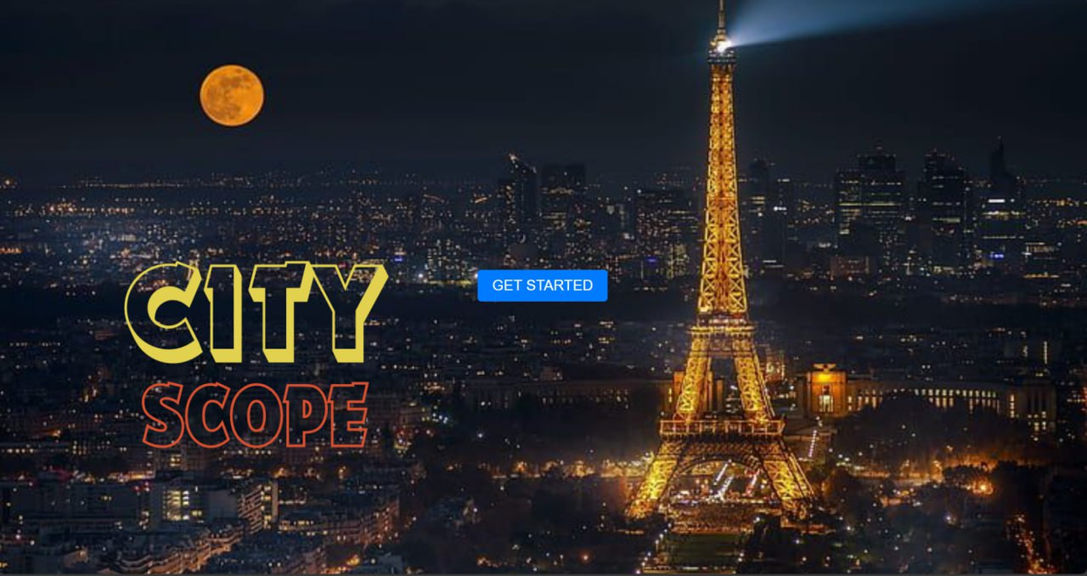

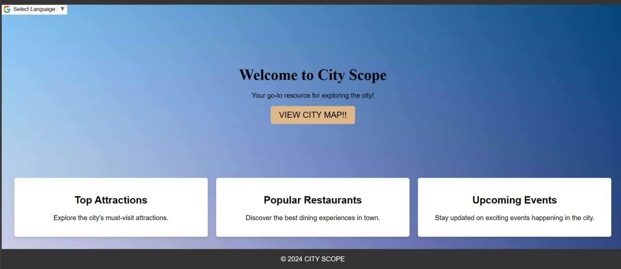

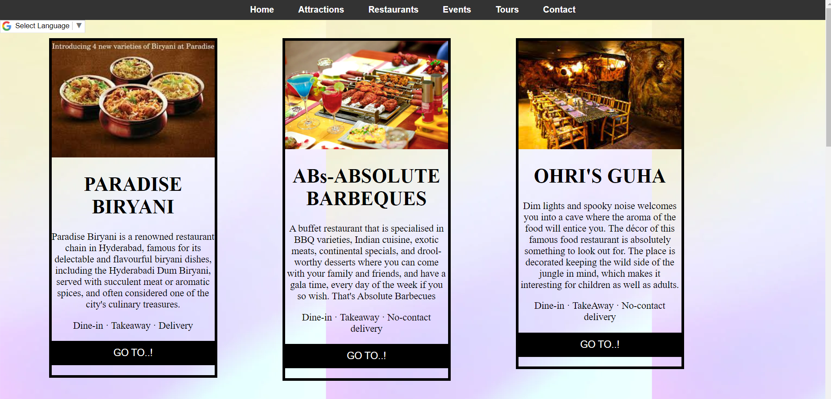

**Appendix C**

**Data sets used in the project**

The City Scope project relies on diverse datasets to enrich user experiences and improve navigation. These datasets include:

1. City Infrastructure Data:

- Information on roads, landmarks, public transportation routes, and other essential urban infrastructure to support accurate navigation.

2. User Interaction Data:

- Collected data on user preferences, behavior, and interactions with the platform to facilitate personalized recommendations and enhance user engagement.

3. Real-Time Events Data:

- Live data feeds on local events, festivals, and activities to provide users with up-to-date information and foster community engagement.

4. Accessibility Information:

- Data on accessibility features in public spaces, including ramps, elevators, and other amenities, to cater to users with diverse needs.

5. Environmental Data:

- Information on air quality, weather conditions, and other environmental factors, contributing to sustainable and informed city exploration.

6. Community-Generated Content:

- User-generated reviews, ratings, photos, and comments providing authentic and diverse insights into city locations, contributing to a collaborative community-driven platform.

7. Augmented Reality Assets:

- Assets and data for augmented reality features, including geo-tagged information about points of interest to enhance the immersive exploration experience.

8. Machine Learning Training Data:

- Historical user data used to train machine learning algorithms for personalized recommendation features.

These datasets collectively empower the City Guide project to deliver a comprehensive, real-time, and user-centric urban exploration experience, ensuring accuracy, personalization, and community engagement within the platform.